Executive Summary

The University of California, Merced is committed to achieving zero-landfill waste by 2020. This Zero Waste Diversion plan is intended to be a living document that highlights the pathway the campus has chosen to achieve and maintain this goal. This plan will also ensure the campus meets the requirements of the University of California Policy on Sustainable Practices and comply with Chapter 18.5, the “State Agency Integrated Waste Management Plan,” in California Public Resources Code Section 40196.3. It will also inform on campus and regional waste management practices, options, evaluate progress towards policy goals and determine the costs of achieving policy goals for campus-wide zero waste.

Per the University of California Policy on Sustainable Practices’ definition on Zero Waste, UC Merced’s zero waste goal is made up of incremental waste reduction and waste diversion targets. The University recognizes the attainment of reduction goals stated in this Policy and a 90% diversion of municipal solid waste as the minimum compliance standard to be defined as zero waste for locations other than health locations.

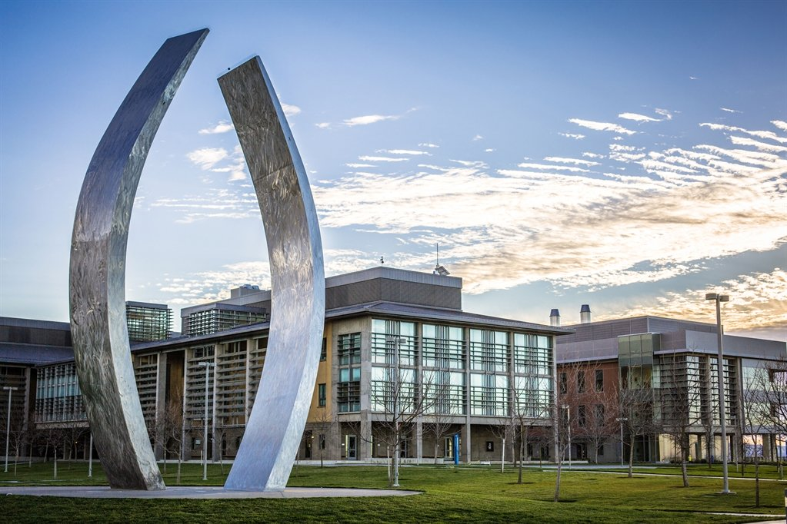

Table of Contents
Executive Summary 2
Site Overview: Waste Reporting Boundaries and Facilities Inclusion 6
Weighted Campus User 7
California Legislation and Regulations regarding Solid Waste 7
Zero Waste Goal 9
Current Waste Operation 10
History of Waste Diversion at UCM 10
Logistics: Hauling and Disposal 13
Material Recovery Facilities used by UC Merced 13
Waste Operations Overview 14
Housing & Dining 14
Recreation and Athletics 15
2020 Project 15
Environmental Health and Safety 15
Academic Core 16
Offsite Facilities 17
Procurement 17
Achievements 18
Progress to Date 19
UCOP Waste Reduction Goals are: 19
Overview of the activities and Progress against targets to date. 19
Housing and Dining Diversion Rate Graph 20
Academic Core Diversion Rate Graph 21
Pathway to Zero Waste 22
Best Practice Benchmarks 23
1. Compost in Dining 23
2. Standardized Signage 23
3. Back of the House Waste Stream Management and Standards for Dining with on-going training 23
4. Source Material Consolidation 23
5. Centralized Office Trash Locations 24
6. Zero Waste Event Trainings to Staff, Faculty & Student Organizations 24
7. Housing Move Out Program 24
8. Social Media Campaign around Zero Waste at UCM 24
Waste Cost and Project Funding 25
Housing and Dining Waste 2017 Operational Costs at North Campus 25
Academic Core Operational Cost 26
Education and Outreach 27
Campus Community Garden 27
Bobcat Eats Food Waste & Prevention Program 27
No Food Left Behind 28
ASUCM Sustainability Council 28
EcoReps 29
Summary of Waste Activities 30

Please direct questions or comments to:

Allajah Wheatley
Zero Waste Coordinator
Department of Sustainability
E‐mail: awheatley2@ucmerced.edu
Tel: 209-0228-4862

Portions of this document were reviewed and commented upon by those listed below. This plan will become a living document that reflects input from the entire UC Merced community.

Michael McLeod
Associate Vice Chancellor, Physical Operations, Planning, and Development

Mark Maxwell
Director, Sustainability

Peter Arroyo
Custodial Manager, Housing and Residence Life

Andre Robinson
Custodial Services Manager, Facilities Management

Sean Murray
Associate Director, Campus Dining

Mal Donohue
Director, Environmental Health and Safety

Zuhair Mased
Director, Energy & Sustainability, Facilities Management

Rodney Trevathan
Grounds General Service Manager, Facilities Management

Ernie Solano
Recycling and Waste Services Manager, Facilities Management

Jessica French
Student/Recycling & Composting Student Manager, Facilities Management

Edvardas Dabb Vilciauskas
Associate Director of Housing Facilities

Meagan Torres
Senior Strategic Souring Manager & IT Category Manager, Procurement Services

Breeana Sylvas
Assistant Director of Sustainability

Guillermo Ortiz
Sustainability & Diversity Educational Programs Manager

Site Overview: Waste Reporting Boundaries and Facilities Inclusion
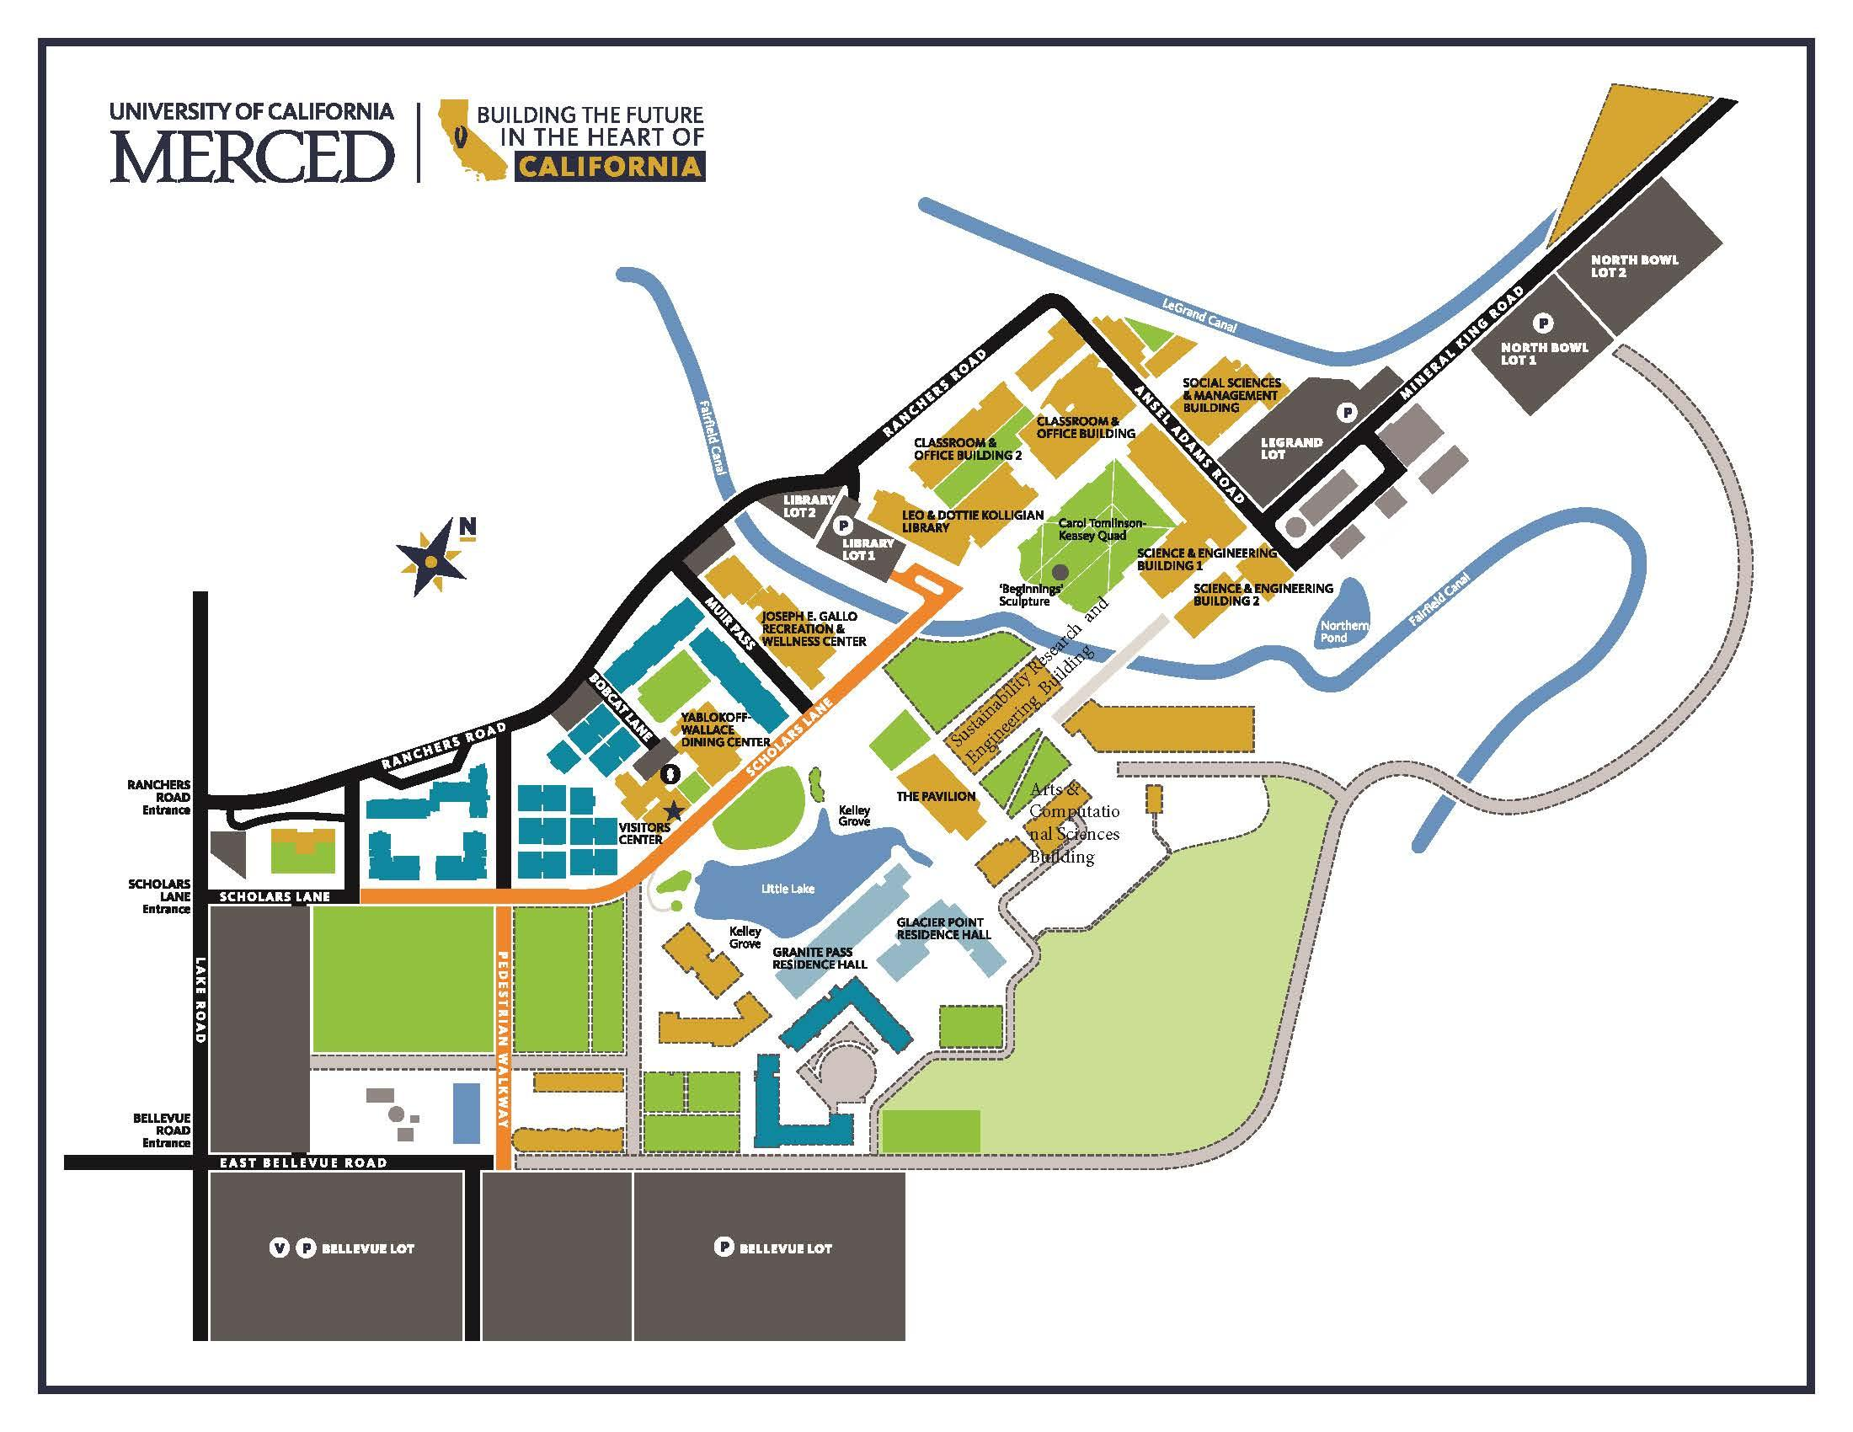
The Site Waste Diversion Plan applies to all waste generated within the UCM campus and one offsite facility known as the Downtown Campus Center.

Site Size - 219 acres
Population - 8,847 students; 1,623 staff/faculty
44 % of student population lives on campus
23 buildings
8 campus housing communities

Exclusions to the boundaries are the Parade Center, Promenade Center, Castle, Fresno Center, and the Off-Campus Housing Apartment buildings.

Weighted Campus User

To report to AASHE Stars and University of California Policy on Sustainable Practices, reporting will be in waste generated per capita per day. Waste generated includes municipal solid waste that goes to landfills and all waste that is diverted through recycling, organics or conversion technologies. Not included in waste reduction calculations are:

- Waste generated as part of major construction and demolition projects
- Organic waste generated due to landscape management
- Agricultural and animal-related waste.

Definition: To determine the Weighted Campus User (WCU), UCM uses the Association for the Advancement of Sustainability in Higher Education’s (AASHE) method (1 x number of on-campus residents) + (0.75 x number of non-residential or commuter full-time students, faculty, and staff members). When using WCU, state whether fall quarter/semester headcount, three quarters/two semesters average headcount or another measure was used in the WCU calculation.

Inclusions are Student, Staff, Faculty

2017-2018 baseline WCU: 7,352
2018-2019 baseline WCU: 8,098

California Legislation and Regulations regarding Solid Waste

- Assembly Bill (AB) 939 (California Integrated Waste Management Act)

In 1989, Assembly Bill 939, known as the Integrated Waste Management Act, was passed because of the increase in waste stream and the decrease in landfill capacity. As a result, the current California Integrated Waste Management Board (CIWMB) was established. A disposal reporting system with CIWMB oversight was established, and facility and program planning was required. AB 939 mandates a reduction of waste being disposed: jurisdictions were required to meet diversion goals of 25% by 1995 and 50% by the year 2000. AB 939 also established an integrated framework for program implementation, solid waste planning, and solid waste facility and landfill compliance.

- Assembly Bill (AB) 341

In 2011, the state legislature enacted AB 341 (PRC Section 42649.2), increasing the diversion target to 75% statewide. AB 341 also requires the provision of recycling services to commercial facilities that generate four cubic yards or more of solid waste per week, and multi-family facilities with five or more units.

- Assembly Bill (AB 1826)

In October 2014, Governor Brown signed AB 1826 Chesbro (Chapter 727, Statutes of 2014), which requires businesses to recycle their organic waste on and after April 1, 2016, depending on the amount of waste they generate per week. Organic waste means food waste, green waste, landscape and pruning waste, non- hazardous wood waste, and food-soiled paper waste that is mixed with food waste. For businesses that generate eight or more cubic yards of organic waste per week, this requirement began on April 1, 2016, while those that generate four cubic yards of organic waste per week needed to have an organic waste recycling program in place beginning January 1, 2017. The requirement becomes more stringent in following years. Multi-family properties are regulated but are only required to divert green waste and non-hazardous wood waste.

- Senate Bill (SB) 1383

“In 2016, Governor Brown signed SB 1383 (Lara, Chapter 395, Statutes of 2016), establishing methane emissions reduction targets that will aid the state in reducing greenhouse gas emissions to below 1990 levels as prescribed in AB 32 (Núñez, Chapter 488, Statutes of 2006). As it pertains to CalRecycle, SB 1383 establishes targets to achieve a 50 percent reduction in the level of statewide disposal of organic waste from the 2014 level by 2020 and a 75 percent reduction by 2025.”3 CalRecycle will enforce organics recycling and edible food recovery targets by January 1, 2022. While CalRecycle is still undergoing formal rulemaking for SB 1383, UC campuses are expected to be beholden to the legislation.

- Senate Bill (SB) 1335: Sustainable Packaging for the State of California Act of 2018

Senate Bill (SB) 1335 (Allen, Chapter 610, Statutes of 2018) was signed into law by Governor Brown. This law prohibits foodservice facilities located in a state-owned facility, operating on or acting as a concessionaire on state-owned property, or under contract to provide food service to a state agency from dispensing prepared food using food service packaging unless it is either recyclable, reusable, or compostable. CalRecycle must adopt regulations by January 1, 2021, that clarify terms, specify criteria, and outline a process for determining the types of food service packaging that are reusable, recyclable, or compostable. CalRecycle will publish a list of approved food service packaging types on its website by March 2021 (within 90 days of the regulations being adopted). As of the writing of this plan, CalRecycle was still undergoing rulemaking for SB 1335.

- Senate Bill (SB) 54/Assembly Bill (AB) 1080 California Circular Economy and Plastic Pollution Reduction Act

Passed in 2019, SB 54/AB 1080 establishes a comprehensive framework to address the pollution and waste crisis and sets a statewide goal of ensuring that manufacturers reduce the waste generated by single-use 2030. Specifically, the bill requires CalRecycle to conduct a robust stakeholder process to develop regulations that:

● Require manufacturers and retailers to design their packaging to reduce unnecessary waste and improve the recyclability or composability of the packaging. Require all single-use packaging to be effectively reusable, recyclable or compostable after 2030.

● Identify the top ten most littered single use plastic products and require these to be manufactured with only recyclable or compostable material.

● Develop incentives and policies to encourage in-state manufacturing using recycled material generated in California.

Zero Waste Goal

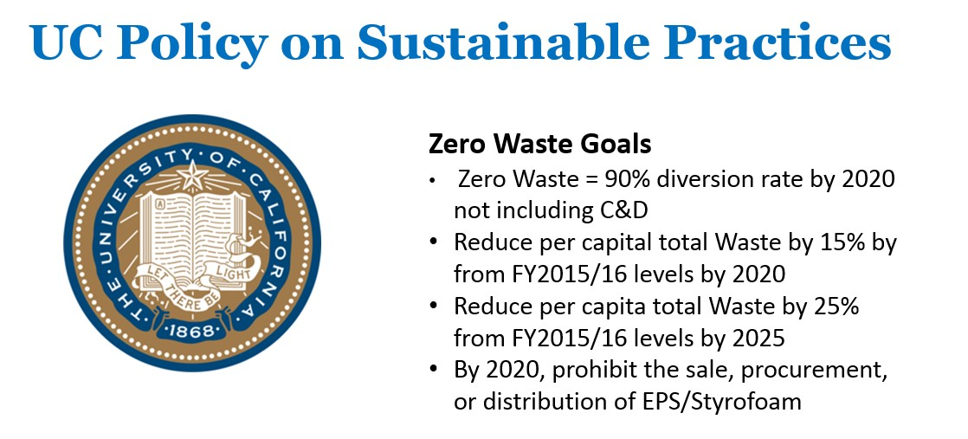

UC Merced strives to achieve the Zero Waste goal from the University of California Office of President (UCOP) by 2020 and per our Triple Zero Commitment.
Zero Waste, as defined by UCOP, is diverting 90% of more campus municipal solid waste from landfills – making the amount of waste produced from the university as close to zero as possible. The UCM campus recycles and composts (#) different commodities.

Current Waste Operation

History of Waste Diversion at UCM

The University of California Merced opened in August of 2005. After opening, waste management operations were as follows:

The Merced County Regional Waste Management Authority operates a landfill located
7 miles from the main campus. UCM sent mixed recycling, but plastics
were limited to bottles and jugs. UCM also sent grass, leaves, trees, and wood to the facility as they have a compost operation for this type of green waste.

The Modesto Compost Facility is 47 miles from the main campus. They are the closest
location that accepts pre-consumer and post-consumer food waste. They did not
accept compostable plastics at that time.

American Recycling is located in Modesto, 43 miles from the main campus. They
accept paper, cardboard, plastic film, mixed rigid plastics and Styrofoam.

Universal Service Recycling is located in Merced, 7 miles from the main campus.
They process scrap metal, glass, and aluminum.

Sorting Line and Single Stream Recycling

In the Summer of 2014, the campus installed a sorting line conveyor system to help with its Zero Waste efforts. A single-stream system is used for recycling plastic, paper, metal, and glass, including recycling and landfill from several designated areas from around campus and bring them back to the sorting location. Students work on this conveyor system to manually
sort the waste daily. After the waste has been sorted, it is brought to the appropriate
local vendor or is picked up by a campus contractor. Since the implementation of
the sorting line in the summer of 2014, the campus diversion rate has increased significantly.
The sorting line was only implemented for six months and the diversion rate increased by nearly 40%. This process provided a detailed look at the actual waste produced on campus.

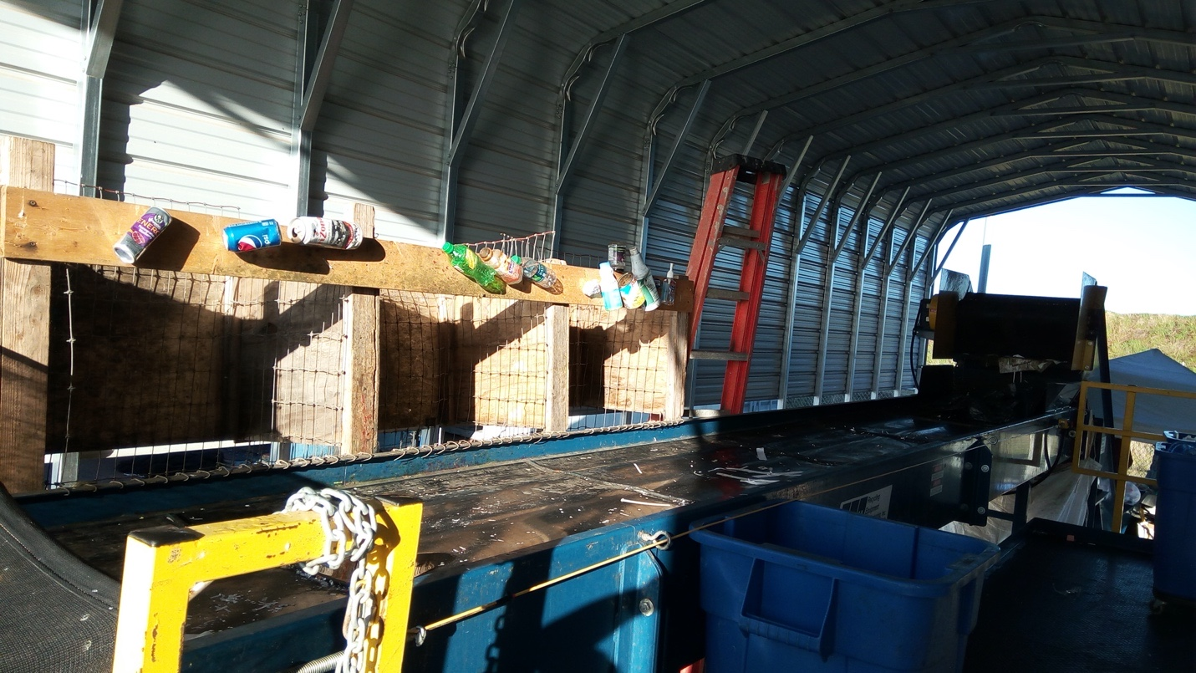

BigBelly Waste and Recycling System

In 2014, the campus started purchasing solar-powered compactors from BigBelly and placing them throughout the campus. They have been custom labeled and have detailed signs that improve the clarity of how to sort waste. The BigBelly systems are aesthetic which causes them to be treated respectfully and encourages individuals to be more conscious about waste. Virtually all other waste receptacles on the main outdoor paths have been removed, so the majority of the campus can easily access the BigBelly systems. The BigBelly systems are connected to the campus internet, so the recycling team can constantly monitor the fullness level of each bin. This allows the recycling team to pick up waste only when necessary and allows a more efficient collection system.
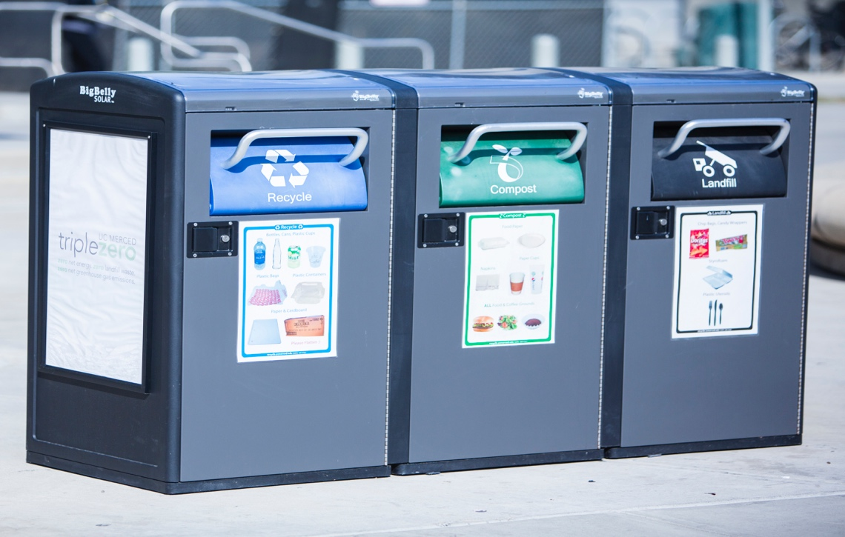

Source Reduction and Reuse Initiatives

Motion-activated paper towel dispensers help reduce excess waste by controlling the length of paper towel dispenser. These have been installed throughout the campus. Also, Dyson Airblade hand dryer systems are installed throughout the campus to help with waste reduction.

Battery recycling containers are located in centralized waste locations in campus buildings. The
recycling staff picks up the batteries which are then sent to a recycler.

Florescent lights are collected by facilities staff and brought to the loading dock. The
recycling staff packages the lights and ship them to a recycler.

Inkjet, toner cartridges, lights, and ballasts are collected by mail services staff and
brought to the loading dock where they are packaged and shipped by the recycling
staff to a recycler.

E-waste is collected by facilities staff and stored in a warehouse where it is later collected
by an e-waste recycler.

Surplus items are collected by facilities staff then stored at a warehouse and eventually
sold at an auction to encourage reuse or repurposed throughout the campus.

Food packaging in the Lantern Café has been modified to align with our zero waste goals. Additionally, the Lantern Café gives a discount for bringing your own cup or mug.
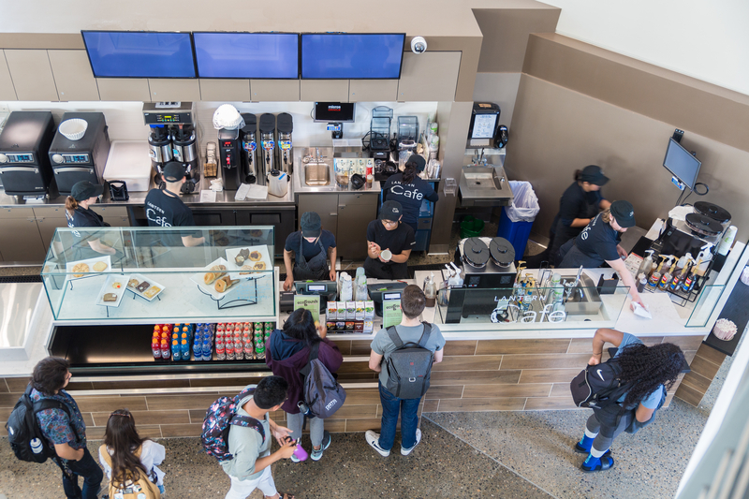

Logistics: Hauling and Disposal

UCM maintains a variety of waste diversion programs to accommodate almost all types of waste exiting the UCM campus. Our program has the capacity to recycle the following materials: plastic film, Styrofoam, bottles, cans, metal, cardboard, wood, mixed recycling, pallets, toners, batteries, e-waste, and wires.

Green waste and food waste are collected and composted off-site.

Material Recovery Facilities used by UC Merced

Category | Company | Data | Address | Contact
- Compost Roll off  - Recreation landfill | Waste Management | Certified Weight Ticker for each load | 730 Industry Way  Atwater, CA 95301 | David Shulman  (209)358-2159
- Paper Gaylords  - Plastic Film  - Styrofoam  - Wires  - Cardboard | American Recycling | Certified Weight Ticker for each load | 2070 Morgan Rd Modesto, CA 95358 | Linden  Coffee  (209)534-2670
- Bottles (Plastic & Glass)  - Cans  - Metal  - Batteries  - E-Waste | Universal Recycling | Certified Weight Ticker for each load | 450 N Tower RD Merced, CA 95341 | Jason Antypass  (209)507-6064
- -Wood  - Mixed Recycling | Merced County Regional Waste Management Authority | Certified Weight Ticker for each load | 7040 N Highway 59  Merced, CA 95348 | Jenifer Halpin  (209)723-3153 ext. 315
- Toner | Xerox  Office Max | Certified Weight Ticker for each load | NA | NA

Waste Operations Overview

Housing & Dining

North Campus housing and dining waste are collected in 2, 40-yard compactors that are located behind the Yablokoff‐Wallace Dining Center. This is hauled off by a vendor, Waste Management. One of the compactors is for mixed recyclables and the other is for mixed waste (food and non‐recyclables). Each housing complex has multiple, 2-yard dumpsters for the students to deposit their waste. The student waste is separated into landfills, recycling, and cardboard. The 2-yard dumpsters are hauled by a vehicle to the two compactors behind dining. Dining also has a cardboard baler for all cardboard. All labor is provided by Housing staff. The following are the types of waste generated from housing:

• Food
• Furniture
• Electronic waste
• Clothes
• Liquids
• Recyclables (bottles, cans, paper, cardboard, etc.)
• Universal Waste (batteries, Ink toners, lightbulbs)
• Personal hygiene products
• Product wrapping

Personal hygiene products, product wrapping, and food represent the biggest contributors to the waste stream. The largest contributor to the waste is the take-out food from food services that becomes a part of the housing waste stream. The Yablokoff-Wallace Dining Center puts all waste and recyclables into the same two compactors at the backside of dining with housing waste, as noted above in housing operations. Cardboard is put into the baler for recycling. Waste generated from dining includes recyclables, food, universal waste, liquid, and trash. Food, recyclables, and trash are the top three contributors to their waste stream. Electronic waste is given to housing and universal waste is coordinated through Environmental Health & Safety (EH&S). The critical item to address in the Dining Center is the composting of food waste. There is currently no composting at Dining, so all compost waste goes to landfill. Below is a pie chart that shows the housing and dining waste diversion rate for the 2018-2019 academic year.

*Disclaimer: Between the academic years for 2016-2018 data was inconsistent and not completely accurate.

Recreation and Athletics

Waste from the Gallo Recreation and Wellness Center goes into the Mariposa and Tuolumne 20-yard landfill containers. This trash is later taken to the housing and dining compactor and hauled off by Waste Management. Their current waste streams include recyclables, food, furniture, universal waste, clothes, paints, varnishes, and liquids. There is no data for diversion from the Recreation & Athletics Centers

2020 Project

The 2020 Project has a Dining building, 4 housing buildings, 3 laboratory buildings, a conference center, an academic office and an aquatics center. Their waste streams mimic the North Campus Housing & Dining system by hauling individual bins from each facility to 2 compactors at the Dining loading dock. The 2 compactors at the Dining Loading Dock are for Recyclables and Landfill waste. The compactors are hauled off by Waste Management services. Similar challenges and opportunities for improvement exist at the 2020 Project like the North Campus Housing & Dining facilities.

Environmental Health and Safety

Though EH&S works mostly with hazardous materials and our zero-waste policy does not currently include hazardous materials, there are materials that they dispose of that could be potentially coordinated with a Zero Waste plan. The current waste streams that EH&S manages include hazardous chemicals, liquid, regulated medical waste & radioactive waste. The top three that represents the waste stream are hazardous chemicals, regulated medical waste and trash. The Office of Sustainability will continue to collaborate with EH&S to find the best methods of disposal for their waste.

Academic Core

The Academic Core consists of the following facilities, most of which are centralized on the North-East portion of the campus:

• Kolligan Library (KL)
• Classroom and Office Building 1 (COB1)
• Classroom and Office Building 2 (COB2)
• Science and Engineering Building 1 (SE1)
• Science and Engineering Building 2 (SE2)
• Social Science and Management Building (SSM)
• Student Services Building (SSB)
• Facilities Services Building A & B (FSA)(FSB)
• Police Trailer
• Academic Office Building (AOB)
• Downtown Campus Center (DCC)
• Early Childhood Education Center (ECEC)

The Academic Core waste is collected and sorted by student employees from Campus Services also known as UCM recycles. Lower campus is not collected because UCM recycles is not large enough to handle the extra workload. UCM Recycles collects all upper campus waste (except SE1&2) and hand sorts it every day. The collection from the various location starts at 6 am to avoid pedestrian traffic. After all, buildings waste has been picked up, it is brought back to the corp yard and placed into carts. It is then emptied on the sorting line, where employees can quickly sort through the different types of recyclable waste to recover as much value as possible. The Academic Core has reached a diversion rate of 84%. We are currently in the low 70 percentile because SE1 & SE2 waste in currently going to the landfill.

Currently, Science and Engineering building 1 and 2 waste is not being collected due to multiple incidents of finding needles or sharps in the waste which has created several injuries. Employees are currently picking up the waste from SE1 and SE2 and taking it directly to the landfill roll-off bin located in the corp yard. When picking up from SE1 and SE2 waste, employees wear the black puncture-proof gloves located in the glove compartment of the recycling truck to prevent further injuries.

Lab hazardous waste is handled by EH&S and is not and cannot be diverted. This hazardous waste includes any chemicals, radioactive and biohazardous waste.

Big Bellies (solar compactors) are collected on Monday, Wednesday, and Friday. Cardboard is picked up from the same locations every day and baled.

Offsite Facilities

A number of facilities are located outside the Merced City limits and are not serviced through the campus, but instead served by their own regional waste management vendors. There is no refuse data in regard to them. These facilities include:

Fresno Center, Buckhorn Flat Ranch, Castle Facilities, Promenade, Venture Labs (Modesto, Los Banos), University House and Wawona Facilities

These facilities are not being captured in our zero-waste metrics.

Procurement

The Procurement Services department is responsible for the acquisition of campus goods and services. The department strives for continuous improvement in processes and practices to maximize value, minimize university risk and promote environmental stewardship in support of the university’s mission of teaching, research, and public service.
Procurement Services’ goal is to drive best practices in sustainable procurement while delivering the best values in goods and services to the university. Procurement services is continually working with vendors, suppliers and the Office of Sustainability to help us with our Zero Waste goals.

Achievements
- Added language to food truck vendors on campus to provide zero waste dishware.
- Incorporated sustainability specifications and evaluation criteria into local contracting processes.
- Implemented sustainable campus-wide standard contracts for furnishings, equipment, supplies, and services focused on environmentally preferable characteristics from the raw material acquisition in manufacturing through the entire life cycle
- Presented sessions on “Environmentally Preferable Purchasing (EPP),” “EPP Best Practices” and “Toxic-Use Reduction” to other UC campuses, institutions, and community groups.
- Hosted three strategic vendor fairs focused on sustainable products and services.
- Initiated a “Building Local Partnerships” event co-hosted by UC Merced Purchasing and the local Greater Chamber of Commerce, with participation from five other public agencies/institutions aimed at fostering relationships with local businesses.
- Managed the bid process through the final contract award and negotiation of campus solar photovoltaic project.

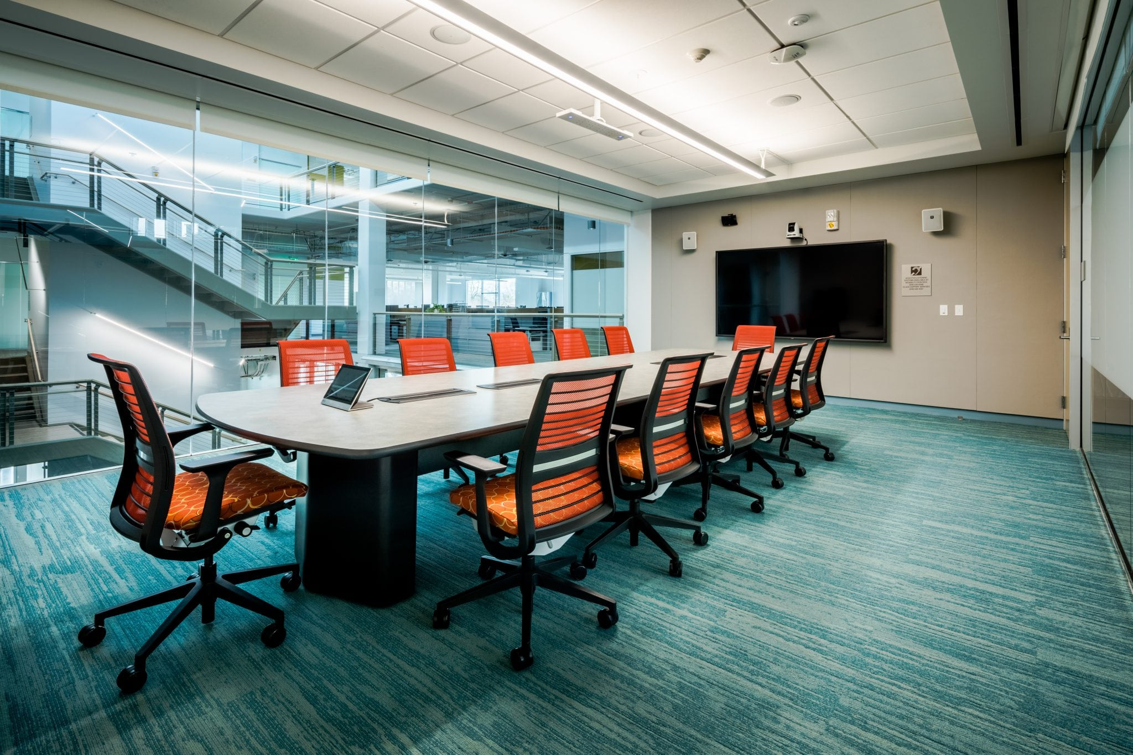

Progress to Date

UCOP Waste Reduction Goals are:

- Achieve zero waste by 2020
- Reduce waste generation per capita to FY2015/16 levels by 2020
- Reduce waste generation by 25% per capita from FY2015/16 levels by 2025
- Reduce waste generation by 50% per capita from FY2015/16 levels by 2030
- By 2020, the University will prohibit the sale, the procurement and distribution of packaging foam, such as food containers and packaging materials, other than that utilized for laboratory supply or medical packaging and products.

Overview of the activities and Progress against targets to date.

*Disclaimer: Between the academic years for 2016-2018 data was inconsistent and not completely accurate.

In 2018, UCM has reached a 1.2 % waste increase. As of 2018, UCM’s diversion rate is 37%, which is lower than in previous years. As seen on the graph, since the 2015-2016 academic year there has been an average decline of 5.6% in the campus diversion rate. To meet the goal of 25% waste reduction due in 2025, the Office of Sustainability, Dining and Waste Management are working to add compost into their waste stream. At the moment, the compost is put into the landfill compactor and is not composted. Adding a compost waste stream in dining has the potential to improve housing/dining’s diversion rate by about approximately 70%. To minimize total waste tremendously, compost needs to be added to dining and housing waste sorted off-site.

Housing and Dining Diversion Rate Graph

The current diversion rate is 19% which is lower than in previous years. Currently, there is no sustainability staff overseeing housing and dining. Also, unlike the academic core, their trash isn’t being sorted. The sustainability department is currently working with auxiliaries to adopt a compost waste stream and sort their commingled trash off-site. The Zero Waste Coordinator is working with the EcoReps and custodial staff to promote Zero Waste in dining and housing.

Academic Core Diversion Rate Graph

Academic Core current diversion rate is 75% which is lower than in previous years. Two buildings, SE1 & SE2, are no longer being sorted, and our haulers are no longer accepting certain materials. Due to numerous incidents of needles being found in Science and Engineering Building 1 and 2, bags from this building stopped being sorted in April 2019. Facilities Management and EHS decided that is was too hazardous to students and staff. Currently, those bags are being picked up by UCM recycling interns while wearing turtle skin gloves, so they are protected from being pricked by needles, and throw directly into landfill. These two buildings produced a substantial number of bags and we immediately have seen a decline in the academic core diversion rate. During the 2018-2019 academic year, our hauler for styrofoam and plastic film began no longer accepting this material. Currently, a hauler for Styrofoam has been found and is still looking for a plastic film hauler.

Pathway to Zero Waste

Currently, there are four areas of the campus that manage their waste separately; Housing and Dining, Recreation and Athletics, EH & S (all hazardous waste) and upper campus. The upper campus includes all the academic buildings, Library, Academic Office Annex building, central plant, police trailers, Logistical Support/Services Facility and all campus grounds.

Upper campus waste is currently managed by Facilities Management also known as UCM Recycling. A recycling coordinator manages a team of student interns that collect waste from each building daily and take it to the corp-yard sorting line in the back of campus for the sorting process. The upper campus has reached a diversion rate of 84% and continues to improve upon that number each year. Additional steps are being taken this year that will push upper campus over 90% waste diversion.

Housing, Dining and the Recreation centers currently have all their waste combined into compactors, one for comingled recyclables and one for mixed waste. Dining’s waste is currently over 90% divertible because its waste stream consists mostly of food waste, but also includes recyclables, liquids, universal waste, and most of the dishware utensils are biodegradable. Housing waste consists of food, furniture, electronics, clothes, liquids, recyclables, universal waste, personal hygiene products, and product wrapping.

Housing and the Recreation Centers waste will now be separated from dining and have their own containers for waste. Their waste will be taken offsite to a material recovery facility that will hand sort their waste to maximize their diversion as we are doing on the upper campus. Housing and the Recreation Centers' commingled recyclables will continue to be combined with dining.

With these changes, along with current operations, the campus will achieve its 2020 zero-waste goal this year.

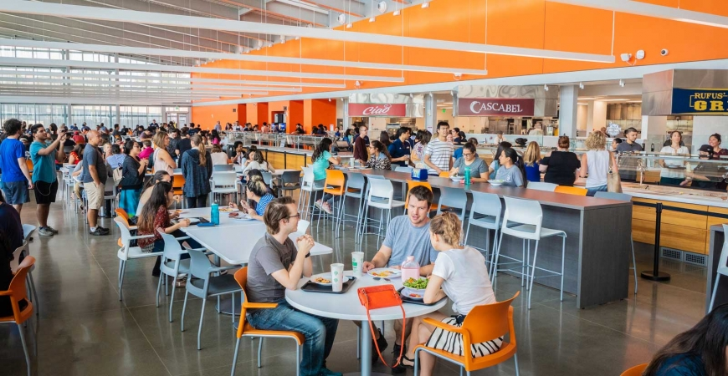

Best Practice Benchmarks

Compost in Dining

Within dining, there are three waste streams, commingled recycling, landfill, and cardboard. In 2019-2020, the Pavilion made the change to dine-in only. With this change, the dining center largely produces food waste. There is no waste stream for compost at the moment. The office of sustainability, waste management, and auxiliaries are currently working on a plan to divert their waste.

Standardized Signage

Above is our current signage for the campus. After, conducting a big belly waste audit and working with a small focus group, it was clear the signs need updating. Some of the information is incorrect or not enough information is given. Also, these are the signs for the whole campus no matter the location. Different locations should have signage relevant to their location. The UCM Zero Waste Coordinator is in the process of creating and implementing new signs for the campus.

Back of the House Waste Stream Management and Standards for Dining with on-going training

Dining is having trouble with contaminating the recycling compactor at the back of dining by not sorting the waste streams efficiently. Collaboration with the UCM Zero Waste Coordinator for ongoing training will help with their sorting efforts.

Source Material Consolidation

To achieve zero waste all materials entering the campus must be recyclable, reusable or compostable. Since we are unable to compost bioplastics ourselves and there is no local recycling market for bioplastics, UCM must halt the purchase of all bioplastics. In addition, food-related paper products must be compostable and not be plastic coated.

Centralized Office Trash Locations

As noted in the 2017 Zero Waste Business Plan, there could be a potential savings across the campus of up to 4100k if custodians did not have to go to each occupant space to pick up the trash and recyclables. If occupants took their trash & recyclables to a centralized area at each floor and the custodians took from there to the first floor, there would not only be money saved in facility operations, but it would make occupants more conscientious of how and what to recycle. The campus has started implementing centralized waste locations in several of the academic buildings and is working on a plan to incorporate all existing buildings. All new buildings within the 2020 buildings have been designed with centralized waste locations. Housing would not participate because students take their trash to the trash shoots or trash containers already.

Zero Waste Event Trainings to Staff, Faculty & Student Organizations

Zero Waste Training is essential to educating staff, faculty, and students about our zero waste goals and their role in helping us reach them.

The Zero Waste Coordinator is focusing on staff and faculty, with a focus on those who do event planning and advising on how to have a zero-waste event. The Office of Sustainability is offering zero-waste event trainings through a request form on the sustainability website.

Our campus-wide engagement fellow is providing zero-waste trainings to student organizations and student governments. This zero-waste training is different and tailored to the students.

Housing Move Out Program

Housing move out produces a substantial amount of landfill waste. Currently, there is no program or policy for move-out. Last year the EcoReps did a pilot move out donation drive and received a vast amount of donations. The most common items being clothing, mini-fridges, microwaves, food and school supplies. The Zero Waste Coordinator, Auxiliaries and Facilities Management are working on a program to implement for housing move-out this year. The Zero Waste Coordinator will work on a marketing campaign with the UC Merced Housing EcoReps to educate students.

Social Media Campaign around Zero Waste at UCM

Currently, UC Merced’s Office of Sustainability utilizes several social media platforms: Facebook, Twitter and Instagram. Using social media helps to expand knowledge on zero waste on campus and improve the presence of our goals. Social media is also used to provide educational videos to answer questions about how to properly dispose of waste and where disposal sites are.

Waste Cost and Project Funding

Housing and Dining Waste 2017 Operational Costs at North Campus

Housing Staffing
(4) Laborers (salaries + Benefits, Uniforms, safety supplies) | $ 228,000
Dining Staffing
(1) Custodian (Salaries + Benefits) | $ 54,000
Waste Management & Hauling Fees
Waste Management Fee Recycling | $ 8,411
Waste Management Fee Waste | $ 27,812
Vertical Baler maintenance and hauling fees | $ 3,800
Maintenance of Yard Containers | $ 8,410
Kubota Truck Maintenance | $ 3,071
Total Operational Costs | $ 333,503
Tonnage of Waste (2015 data) | Tons
Recycling | 77
Cardboard | 39
Landfill | 309
Total | 425
Cost Per Ton | $ 784.43

Academic Core Operational Cost

Housing Staffing
(4) Laborers (salaries + Benefits, Uniforms, safety supplies) | $ 228,000
Dining Staffing
(1) Custodian (Salaries + Benefits) | $ 54,000
Waste Management & Hauling Fees
Waste Management Fee Recycling | $ 8,411
Waste Management Fee Waste | $ 27,812
Vertical Baler maintenance and hauling fees | $ 3,800
Maintenance of Yard Containers | $ 8,410
Kubota Truck Maintenance | $ 3,071
Total Operational Costs | $ 333,503
Tonnage of Waste (2015 data) | Tons
Recycling | 77
Cardboard | 39
Landfill | 309
Total | 425
Cost Per Ton | $ 784.43

Education and Outreach

Campus Community Garden

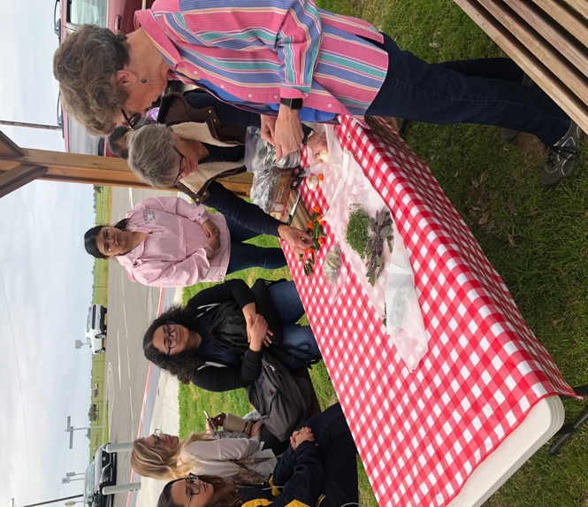
The Campus Community Garden has helped 491 students get hands-on experience growing fresh vegetables and maintaining a garden space. The Campus Garden serves to educate students on healthy options, as well as create more environmentally and socially conscious students. This year, the Garden held workshops such as, “Native Plants and Native People,” where student clubs NISC and CAFÉ led a ceremony to honor the land and held a productive discussion on how we can preserve our planet. Produce grown at the Garden is donated to Bobcat Pantry, who then redistributes fresh food to students in need.

Bobcat Eats Food Waste & Prevention Program
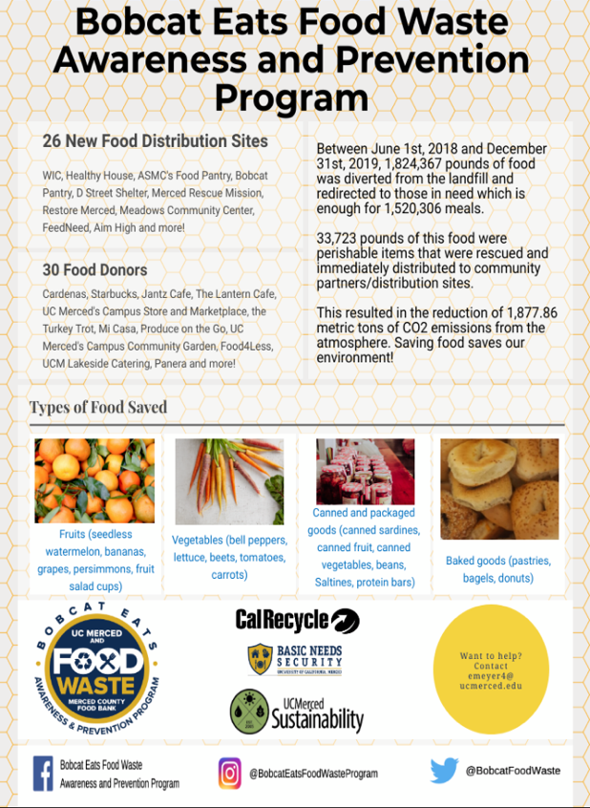
Bobcat Eats Food Waste Awareness and Prevention Program is a collaboration between the University of California, Merced and the Merced County Food Bank with the goals to reduce food insecurity and food waste in the County. There are two main components to this program. One component is harvesting or gleaning food from Merced County farms, backyards, and other food outlets. The second component involves distributing more food to those in need. For 2019, they rescued 1,207,997 pounds of food, partnered with 30 food donors and 26 new food distribution sites.

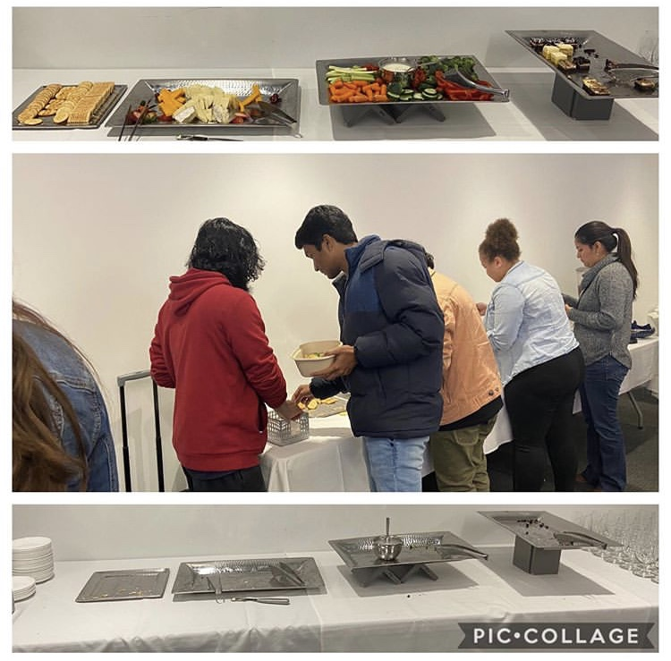
No Food Left Behind

The No Food Left Behind program, an extension of Bobcat Eats, aims to reduce food insecurity and waste on campus by connecting the campus community to Lakeside catered events that have food leftover. When ordering in CaterTrax, there is now an option to donate leftover food, and if selected, the event will be registered as a No Food Left Behind event. Students, faculty, and staff who are not attending but have registered for the program will receive text messages before events letting them know the food may be available after. If food is available, those registered will have 15 minutes after the event to bring food containers and collect leftovers.

ASUCM Sustainability Council

The ASUCM Sustainability Council hosts an Earth Day Festival in April. Students and staff can play games and visit booths for a chance to win prizes. The games facilitate an interaction between recycling interns, sustainability organizations and the campus, to promotes an educational environment for the campus to learn about the correct recycling procedures on campus.

Earth Day Recap Video: https://ucmerced.app.box.com/s/7uy8rvgglfcfqdoa5ujb5a7dxm33ii66

EcoReps

The EcoRep Program aims to educate students on and off campus about sustainable behaviors that benefit our community and the environment. These goals are attained by using peer education techniques. The EcoReps makes sure that students teach students in the most effective way possible. The Eco-Rep program aims to educate students about sustainable practices that benefit the community and environment. The goal is to encourage environmental behaviors in all topics related to sustainability, focusing on sustainable living practices using peer education techniques to inform students. This academic year the EcoReps biggest events were a pilot donation drive, virtual tours of sustainable places on campus and cooking events with Pavilion Chef Matt.

Virtual Tour of the Corpyard: https://ucmerced.box.com/s/v3pt15vyp1pc26c6mxfdzmhr4sw25nkj

Chopped Cat: https://ucmerced.box.com/s/3st7x2vk6f0ojsmfy107v126jj29hs4z

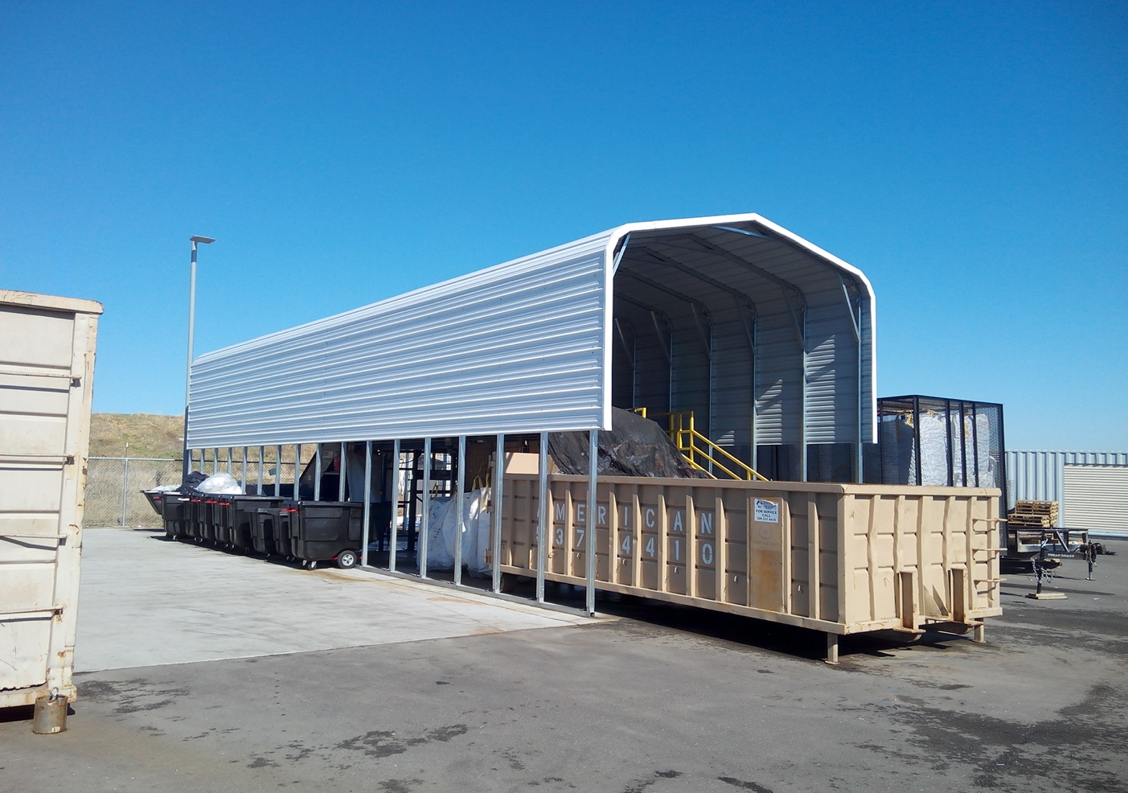

Summary of Waste Activities

Type | Disposal Method | Handling Procedure | Hauler
Commingled Materials | Commingled material is collected inside of the academic core areas. The material is transferred from the interior into rolling carts by custodial staff. | The UCM recycling interns collect the bags from the various buildings and take them back to the corpyard. The commingled material is then sorted on the sorting line and put in their various waste streamed and picked up or taken to its hauler. | UCM Custodial Staff  UCM Recycling Interns  Waste Management
Compost (Green Waste) | Grass, leaves and tree clippings are transferred daily by the grounds crew to the corpyard. The green waste is taken as needed. | The green waste is loaded into a 40 yard roll off. When full Waste Management is called, and they haul the green waste Modesto Compost. | UCM Groundskeeper  Waste Management
Landfill & Recycling  (Dining) | Dining Waste is taken down to the loading dock and placed in a 35yrd compactor. Landfill is picked up three times a week by waste management. | Custodial Staff and dining student workers take the trash to the compactors at the loading docks. | UCM Custodial Staff  Waste Management
Metal | Departments must fill out a facilities management work order. They also have the option to drop it off at the recycling center. | The metal is then taken to universal recycling and the hauler recycles the items. | UCM Recycling Interns  Universal Recycling
Batteries | Facilities Management provides battery bins labeled located in the various buildings on campus. | The bins are collected when full by UCM Recycling interns. The batteries are sorted and stored in and then picked up by | UCM Recycling Interns  Universal Recycling
E-Waste | Departments must fill out a facilities management work order to get a large order picked up. They also have the option to drop it off at the recycling center. | The e-waste is taken to Universal Recycling and the hauler recycles the items. | UCM Recycling Interns  Universal Recycling
Cardboard. (Academic Core) | The janitorial staff pick up cardboard throughout the building and placed them in the various locations rolling carts. The UCM recycling interns pick up cardboard once a day. | UCM recycling intern takes the cardboard and bales it in COB2 loading dock. Once there are 3 bales or more shipping and receiving forklifts the bales to the recycling center. America Recycling hauls the bales away and recycle the material. | UCM Recycling Interns  UCM Shipping & Receiving  American Recycling
Wood | Departments must fill out a facilities management work order to get a large order picked up. They also have the option to drop it off at the recycling center | Wood is dropped off at the corpyard. Once there is enough wood to fill up the truck. It is taken to Merced County and recycled. | UC Merced Shipping & Receiving  UCM Recycling Interns  Merced County
Pallets | Pallets are dropped off at UCM recycling center from various entities on campus. Departments can also fill out a work order for them to be picked up. | Pallets are reused within the corpyard such as under bales of cardboard or paper gaylords. Other departments reuse them as well for various projects. | UCM Recycling Interns
Toners | Toners are dropped off in various marked trash cans and picked by custodial staff or the recycling interns. | UCM recycling interns places all toners in a xerox box and another box for all other brands. Each brand boxed are placed on separate pallets. When there are four boxes for each the palettes are plastic wrapped and shipped to Xerox and Office Max. | UCM Custodial Staff  UCM Recycling Interns  Shipping & Receiving  Xerox  Office Max

